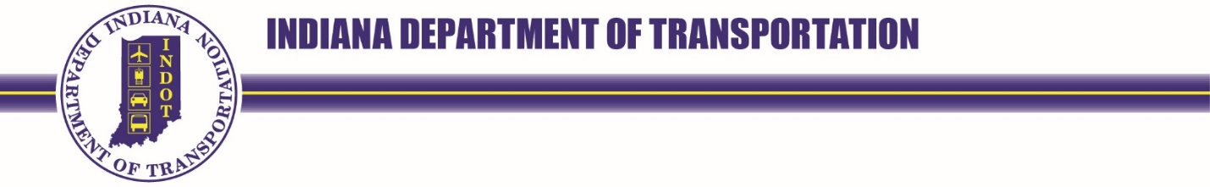
100 North Senate Avenue  Room N758  Indianapolis, Indiana 46204 | PHONE: (855) 463-6848 | Eric Holcomb, Governor  Michael Smith, Commissioner

NOTICE OF OPEN SESSION OF THE
PREQUALIFICATION COMMITTEE
THURSDAY, June 1, 2023, 9:00 AM (Executive); 9:30 A.M. ET (Public)
IDOA CONFERENCE CENTER- HARRISON HALL CONFERENCE ROOM 17 (IGC South)

AGENDA
- Executive Session (9:00 AM to 9:30 AM)
THE PREQUALIFICATION COMMITTEE WILL MEET IN EXECUTIVE SESSION TO REVIEW CONFIDENTIAL INFORMATION PURSUANT TO 105 IAC 11-2-4(d) AND IND. CODE § 5-14-1.5-6(b)

- Call Public Session to Order Serak
- Consent Agenda Serak
  - Minutes of May 4, 2023 Committee
- Committee Procedural Update Serak
- Prequalification Division Update Goralski & Weaver
- New Business Open
- Public Comment Open

Next PQC Meeting July 6, 2023 @ 9 A.M- IDOA Conference Center, Harrison Hall Conference Room 17

